

Topic test 1
Name: __________________________________

Chapter 8: Arithmetic and geometric sequences

- Time allowed: 45 minutes
- CAS calculators may be used.
- Part A: 5 multiple-choice questions (5 marks)
- Part B: 8 short answer questions (16 marks)
- Part C: 2 analysis questions (6 marks)
Part A
5 multiple-choice questions
1 mark each: 5 marks
Circle the correct answer.
1 What is the common difference of the sequence 23, 32, 41, … ?
A 23
B 10
C 9
D 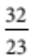
E 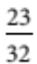

[1 mark]

2 What is the common ratio of the sequence  45, 15, 5, …?
A 45
B 30
C
D –30
E 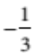

[1 mark]
3 What is the twentieth term of the sequence 3, 8, 13, …?
A 98
B 20
C 100
D 103
E 93

[1 mark]
4 What is the eighth term of the series 3  6 + 12  …?
A 8
B 1536
C 1536
D 384
E 384

[1 mark]
5 Which of the following series has a limiting sum?
A 2 + 3 + 4 + …
B 2 + 3  4 + …
C 4 + 3 + 2 + …
D 4  2 + 1  …
E 4  3 + 2  …

[1 mark]
Part B
8 short answer questions
16 marks
Show your working where appropriate.
1 Evaluate to 7 terms: 4  7  10  13  …

[2 marks]
2 Evaluate to 8 terms: 3  6  12  24  …

[2 marks]
3 Find the limiting sum of 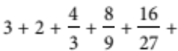 …

[2 marks]
4 The first and last term of an AP containing 29 terms are 16 and 128 respectively. What is the sum of all terms in the sequence?

[2 marks]
5 The first and fifth terms of a GP are 5 and 3125 respectively. What is S5 for this sequence?

[2 marks]
6 The last term of an arithmetic sequence is 642 and the common difference is 13. How many terms are positive?

[2 marks]
7 The fifth term of a geometric sequence is 243 and the seventh term is 2187. What is the sum of the first 6 terms?

[2 marks]
8 Using your knowledge of a sum to infinity, write 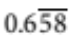 as a simplified fraction. Show all working.

[2 marks]

Part C
2 analysis questions
6 marks
Show your working where appropriate.
1 Bailey bought a one-bedroom unit for $360 000. He paid $90 000 cash and took out a loan for the remainder. Under the terms of the loan, Bailey agreed to repay $1500 each month plus interest of 6% p.a. on the unpaid balance. If he followed this agreement until the loan was paid out, how much did he pay altogether?

[3 marks]
2 Merenda bought a one-bedroom unit for $360 000. She paid $90 000 cash and took out a loan for the remainder. Under the terms of her loan, Merenda agreed to make a payment each month with interest of
6% p.a. on the unpaid balance until the loan was paid out. Her loan was taken out over 20 years, how much
did she pay altogether?

[3 marks]
[Total marks: 27]

Answers
Part A [1 mark each]
1 Common difference  41  32 = 32  23  9
∴ C [1 mark]
2 Common ratio  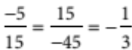
∴ E [1 mark]
3 t20  3  19  5  98
∴ A [1 mark]
4 t8  3  (−2)7  −384
∴ E [1 mark]
5 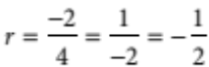 , ∴r <1
∴ D [1 mark]
Part B
1 4  7  10  …  22 [1 mark]
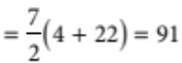 [1 mark]
2 3  6  12  24  48  96  192  384 [1 mark]
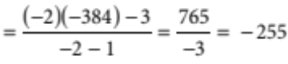 [1 mark]
3 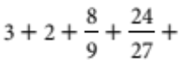… [1 mark]
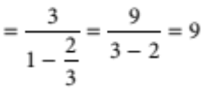 [1 mark]
4 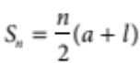
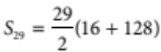 [1 mark]
S29  2088 [1 mark]
5 t5  5  r4  3125
∴ r4  625, r  5 [1 mark]
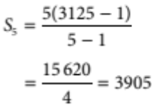 [1 mark]

6 642  629  616  …
∴ 642  (n  1)  (13) > 0 [1 mark]
13n >  655
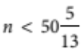
n  50 [1 mark]
7 ar4  243
ar6  2187
∴ r2  9
r  3 [1 mark]
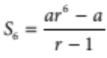
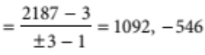 [1 mark]
8 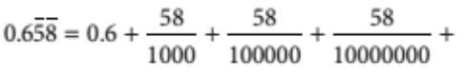…
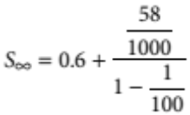 [1 mark]
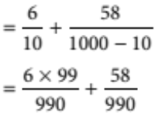
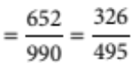 [1 mark]
Part C
1 Cash  $90 000, Loan  $270 000
First payment  $1500  0.005  270 000  $2850.00
Second payment  $1500  0.005  268 500  $2842.50
Third payment  $1500  0.005  267 000  $2836.00
Last payment  $1500  0.005  1500  $1507.50
From the first three, each payment decreases by $7.50. [1 mark]
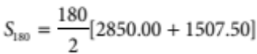
 $392 175 [1 mark]
Total paid  $90 000  $392 175  $482 175 [1 mark]

2 A1  $270 000  1.005  M
A2  $270 000  1.0052  M  1.005  M
A3  $270 000  1.0053  M  1.0052  M  1.005  M
:
A240  $270 000  1.005240 − M  1.005239  M  1.005238  …  M [1 mark]
Since A240  0, by rearranging this expression we get
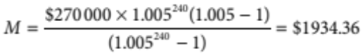 [1 mark]
∴ Total paid  240  $1934.36  $90 000
 $554 247.33 [1 mark]

